Time to design
Do you want to win prizes?

We are the JRSOs (junior road safety officers) and we want to help make you and the roads around school safe!
Over the summer term we will be organising competitions for you all to enjoy.
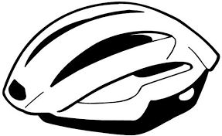

Over the Easter holidays we would like you all to design a helmet using your imagination. Thinking about what will help us to stay safe on the roads.
We will be judging the entries the first week back after Easter.
We look forward to seeing your designs.
Jack and Daisy
Year 5

